Question(s): | 5 |  | Meeting, date: |  | Geneva, 17-21 November 2003
Study Group: | 13 | Working Party: | 2 | Intended type of document (R-C-D-TD): |  | D
Source: | RAD Data Communications
Title: | Comparison of AAL2oIP with Multiplexed VoIP
Contact: | Yaakov (Jonathan) Stein  RAD Data Communications  ISRAEL |  |  |  | Tel: +972 3 645-5389  Fax: +972 3 647 5924  Email: Yaakov_S@rad.com
Contact: |  |  |  |  | Tel:  Fax:  Email:
Please don’t change the structure of this table, just insert the necessary information.

Abstract
Living list item 8 deals with voice trunking over IP. Contribution D391 from the last meeting proposed an AAL2-based trunking mode, similar to that in Y.vsmpls. That contribution claimed that such a mode could greatly improve bandwidth efficiency for trunking applications as compared to standard VoIP. Proof of this contention was requested, and in particular a comparison of AAL2oIP's efficiency as compared with VoIP with and without header compression. The present contribution presents the required proof.

Motivation for AAL2oIP
In certain applications point to point transport of multiple compressed voice channels is required. One prevalent example of such a voice trunking application is toll-bypass, where a service provider with an IP connection sells telephony services that compete with traditional long-distance services. The service provider desires to utilize the bandwidth of the IP connection as frugally as possible.
The conventional implementation for voice trunking over IP networks involves the set-up and running of multiple VoIP connections. Since typical compressed voice packet payloads are relatively small (10 to 48 bytes), while conventional L2 plus UDP/IP plus RTP are larger (e.g. for Ethernet 18+28+12=58 bytes), the transport efficiency is extremely low.
There are several possible methods to improve the efficiency. First, one may employ "superpackets", consisting of several successive payloads. Unfortunately, this tactic greatly increases the buffering delay, and thus great increases the already high round-trip delay. This further reduces the users perception of voice quality, and can push the system over the one-way transmission time limits set by G.114.
Second, one can decrease the overhead size by employing "header compression" techniques. These typically reduce the UDP/IP or UDP/IP+RTP headers to a small number of bytes, but do not eliminate the L2 overhead. Compressed header packets are not standard IP packets, and require routers or edge equipment that are header-compression-aware. In addition, header compression functions best for single-hop, low-delay, zero-packet-loss links. In the presence of packet loss, header compression further degrades the perceived voice quality.
Third, for voice trunking one can combine the payloads of multiple voice channels into a single packet, thus incurring only a single overhead for large numbers of channels. This method has no serious disadvantages, as it does not add delay, does not require special edge equipment, and has no additional detrimental effect in the presence of packet loss.
The standard ITU method of voice trunking is AAL2, standardized in I.363.2 and I.366.2, and now widely deployed (for example, in VoDSL and UMTS cellular backhauling). SG13 has included an AAL2 mode in Y.vsmpls, and the MPLS-Frame Relay Alliance has approved an implementation agreement that utilizes AAL2 over MPLS for this application.

AAL2oIP vs. VoIP Efficiency Comparison
For the sake of our comparison we assume that one of the ITU standard speech compression methods is employed. The relevant details are included in Table 1.

Standard | Bit-rate | Buffer interval | Payload bytes | Payload in double sized superpacket
G.729 | 8 Kbps | 10 millisec | 10 | 20
G.723.1 | 5.3 Kbps | 30 millisec | 20 | 40
G.723.1 | 6.3 Kbps | 30 millisec | 24 | 48
Table 1 Relevant specifications of ITU-T standard speech compressions

An AAL2 CPS packet (minicell) is capable of handling payload sizes of up to 64 bytes, so all payloads are handled without fragmentation, and hence incur a single 3 byte CPS header overhead per channel. The maximum number of channels that can be handled by a single AAL2 stream is 248.
The efficiencies for AAL2 and VoIP are given by
AAL2-efficiency = (N * payload) / ( L2 + L3 + CW + N*(3+payload))
VoIP-efficiency = (N * payload) / (N * (L2 + L3 + payload))
= payload / (L2 + L3 + payload)
where
N is the number of channels
Payload is the payload size in bytes (from Table 1)
L2 is the layer 2 overhead in bytes (at least 6 bytes for PPP, 18 bytes for Ethernet,
22 bytes for VLAN, 26 bytes for 802.3).
L3 is the layer 3 overhead (plus RTP if needed) in bytes
CW is the length of the common interworking indicators ("control word") in bytes (always 4).

Note that in the formula for VoIP there is no N dependence, since no overhead sharing is performed.
In our first sequence of comparisons we assume that (uncompressed) UDP/IP headers are employed. Hence UDP/IP = 28, RTP=12, and so L3=40 for VoIP and L3=28 for AAL2oIP.
AAL2-efficiency = (N * payload) / ( L2 + UDP/IP + CW + N*(3+payload))
VoIP-efficiency = payload / (L2 + UDP/IP + RTP + payload)
In order to cover all possible L2 cases, we plot the efficiency as a function of L2 overhead in the range up to 26 bytes. In each plot we include curves for all five distinct payload sizes, for both VoIP and AAL2oIP.
Figure 1 we present the results for four channels. Even for this low channel occupancy the efficiency advantage of AAL2oIP is clear. This advantage improves with increasing N, as observed in Figure 2 (N=12 - half T1), Figure 3 (N=30 - full E1), Figure 4 (N=100), and Figure 5 (N=200).

Next we consider the effect of header compression. Although RFC 2508 joint IP/UDP/RTP header compression is probably not directly applicable, the enhanced CRTP of RFC 3545, or ROHC of RFC 3095 may be appropriate. All such compressions rely on saving state or first order differences of various fields. When the fields are not as expected the complete field value must be transmitted, and therefore the compressed header contains a bit map specifying which field are present. In order not to enter into doubtful statistical calculations, we take 4 bytes as the average compressed L3 header, which is certainly an underestimate assuming that checksums are being used (which would be required for long-haul links, and is need for use of the 2508's "twice" algorithm).
AAL2-efficiency = (N * payload) / ( L2 + 4 + CW + N*(3+payload))
VoIP-efficiency = payload / (L2 + 4 + payload)
In Figures 6 (N=4), 7 (N=12), 8 (N=30), 9 (N=100) and 10 (N=200) we see that even with compressed headers AAL2oIP is more efficient than multiple VoIP connections, for all realistic L2 sizes. For low L2 overhead (e.g. minimal PPP) VoIP fares relatively well, but as the L2 overhead increases it dominates the VoIP efficiency, while scarcely affecting the AAL2oIP numbers.

In order to better visualize the effect of N on the efficiency, we present a final sequence of plots wherein we depict the efficiency as a function of the number of channels. Figure 11 displays the efficiencies for a minimal PP link and uncompressed headers, while Figure 14 displays the same case for compressed headers. Since VoIP's efficiency has no N dependence, its curves are all constant. In contradistinction to this behaviour, AAL2oIP rapidly benefits from increasing N. The differences are always significant, but are smaller for compressed headers, low N, and large payload sizes. Similarly Figures 12 and 15 depict the same behaviour for Ethernet, and Figures 13 and 16 for 802.3.

Proposal
Due to efficiency gains herein demonstrated, prior standardization, ease of interworking, and use of a well-known and widely deployed technology, it is hereby proposed to base "voice trunking over IP" on AAL2.

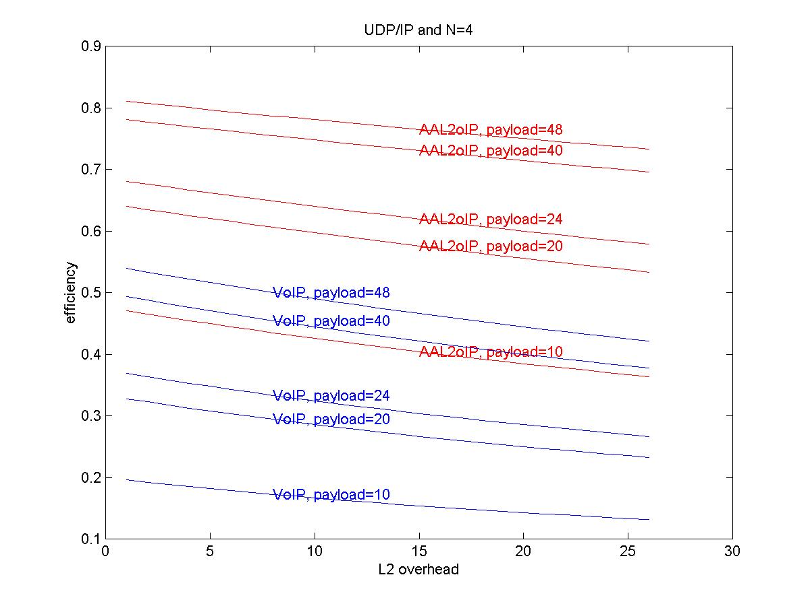
Figure 1
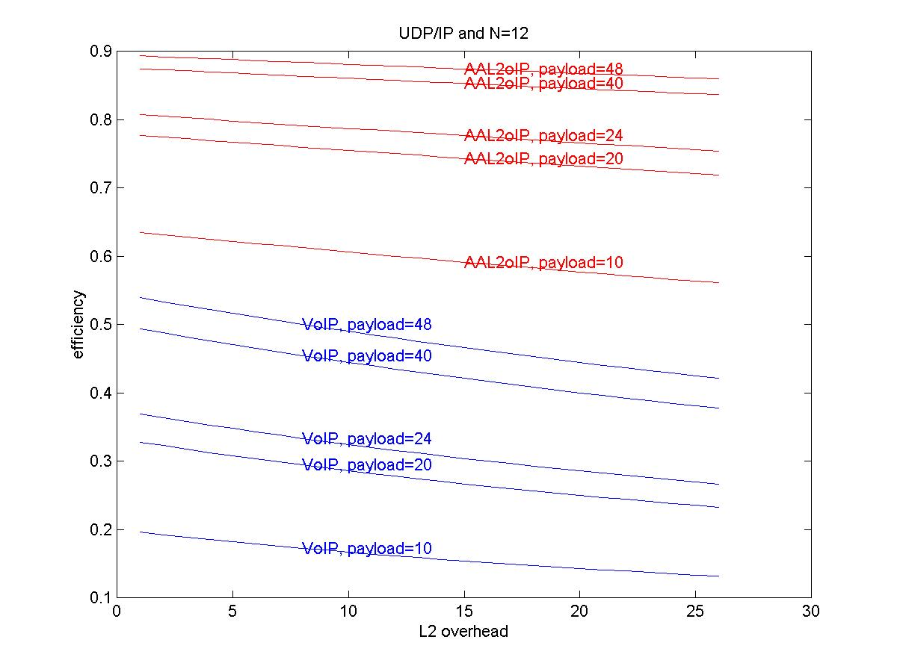
Figure 2
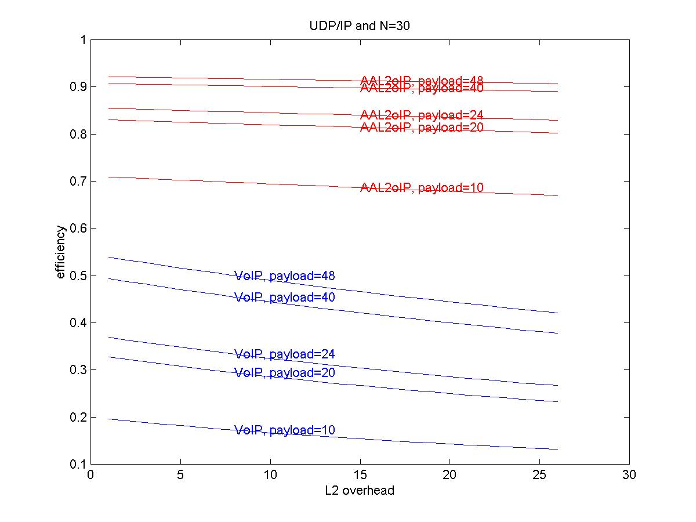
Figure 3
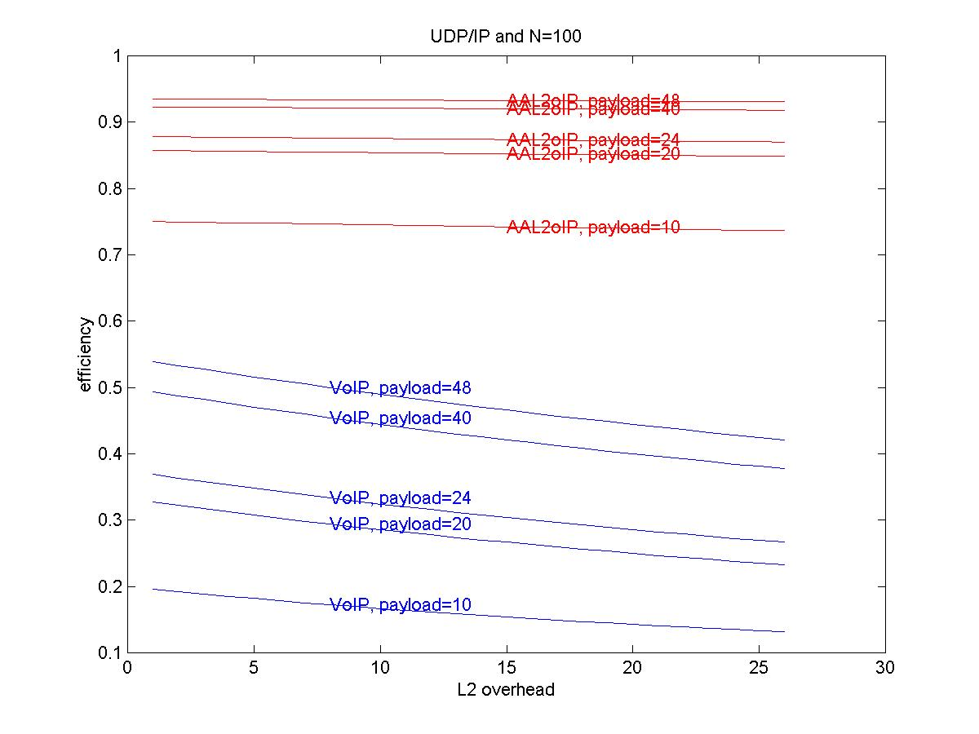
Figure 4
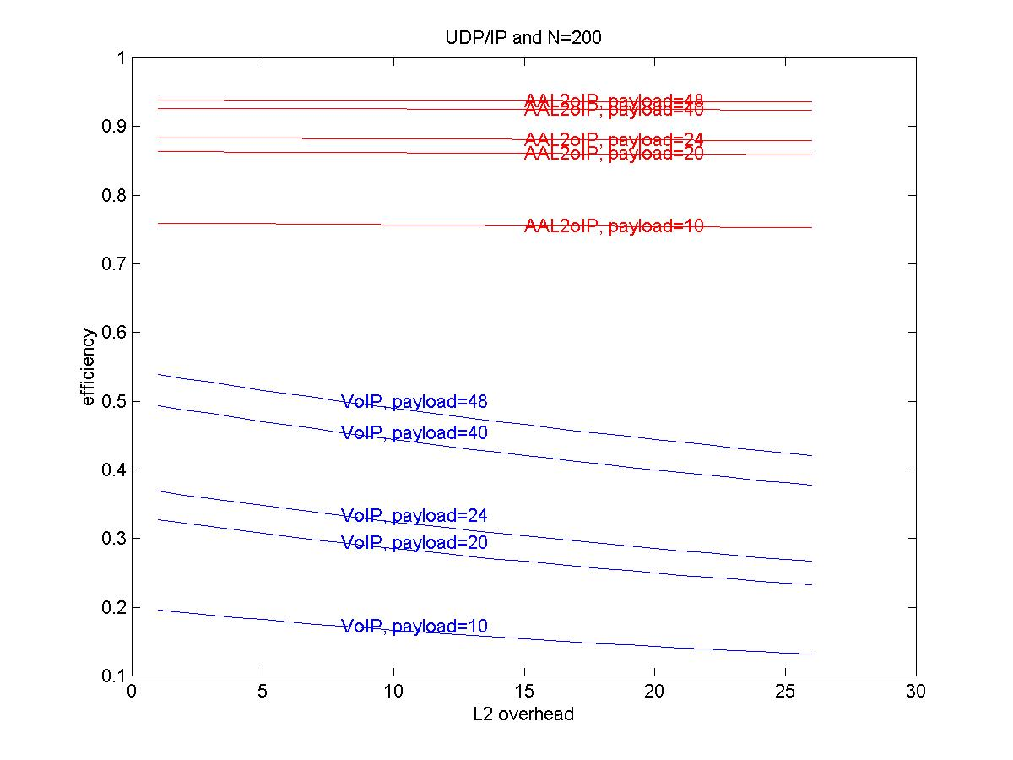
Figure 5
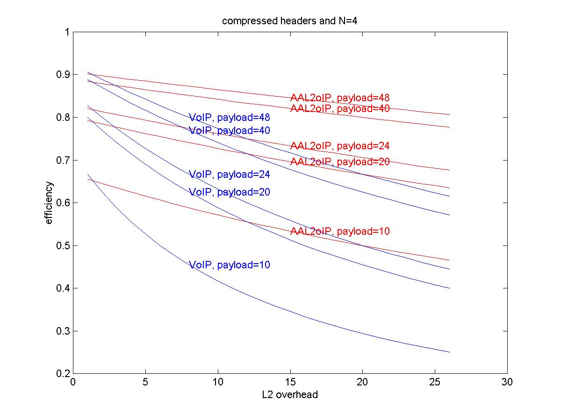
Figure 6
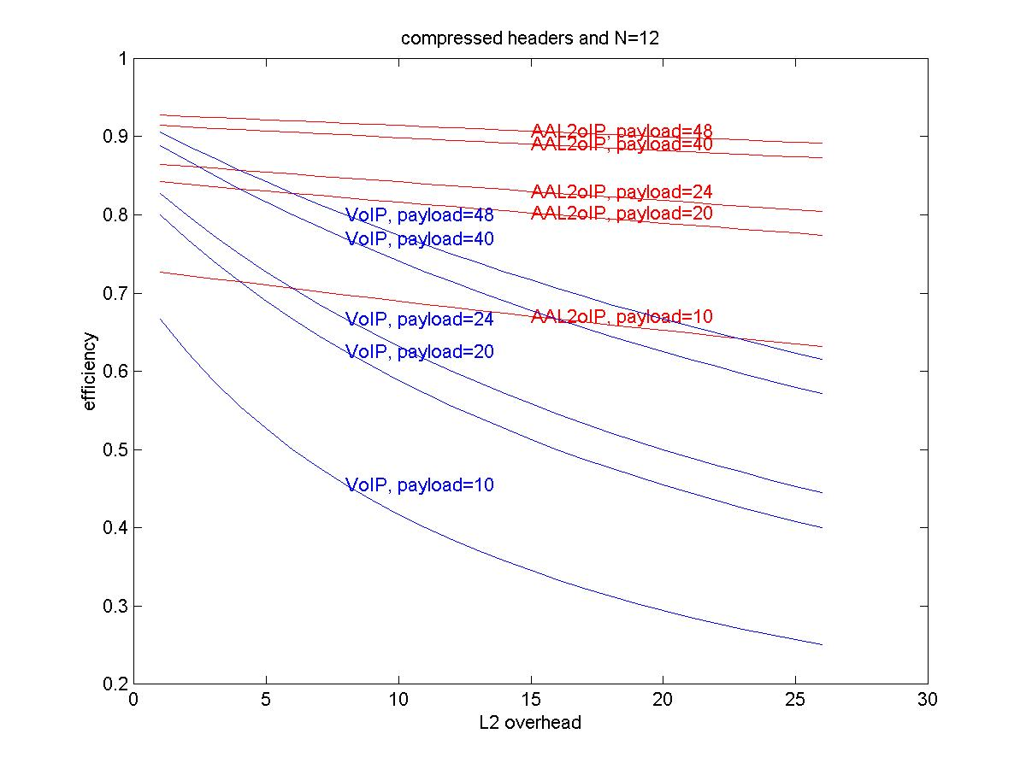
Figure 7
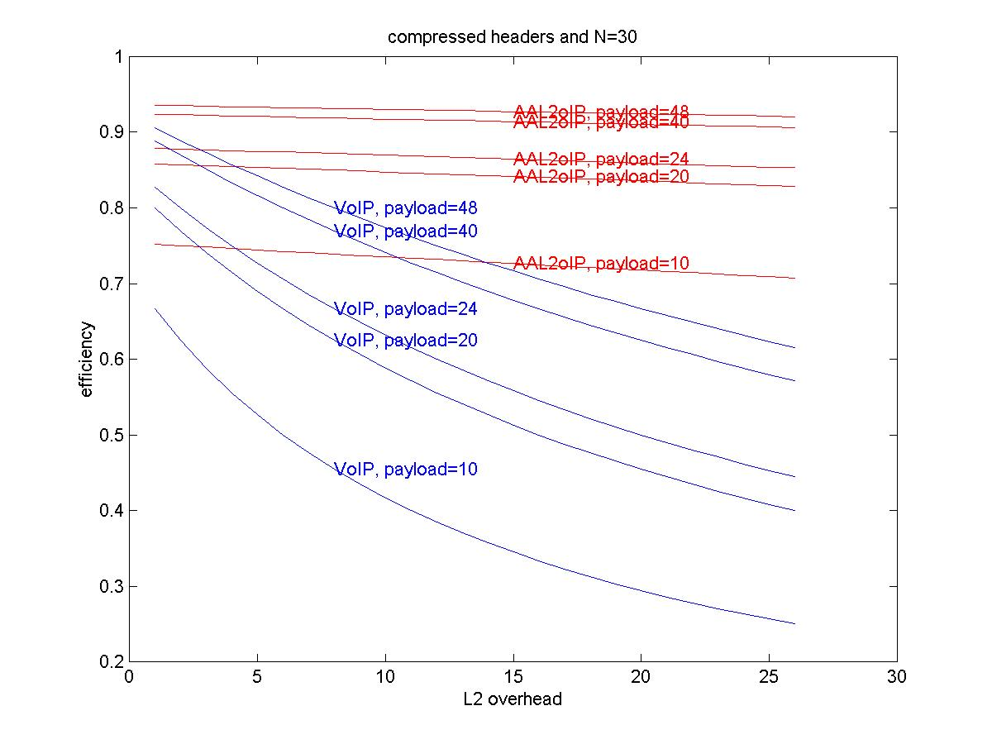
Figure 8
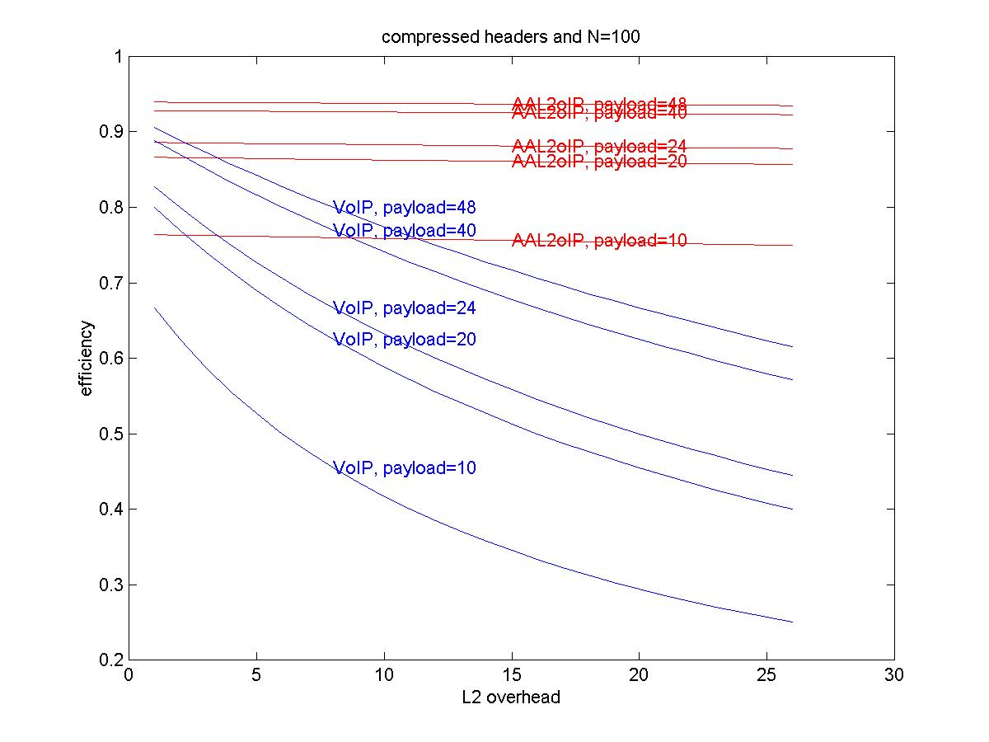
Figure 9
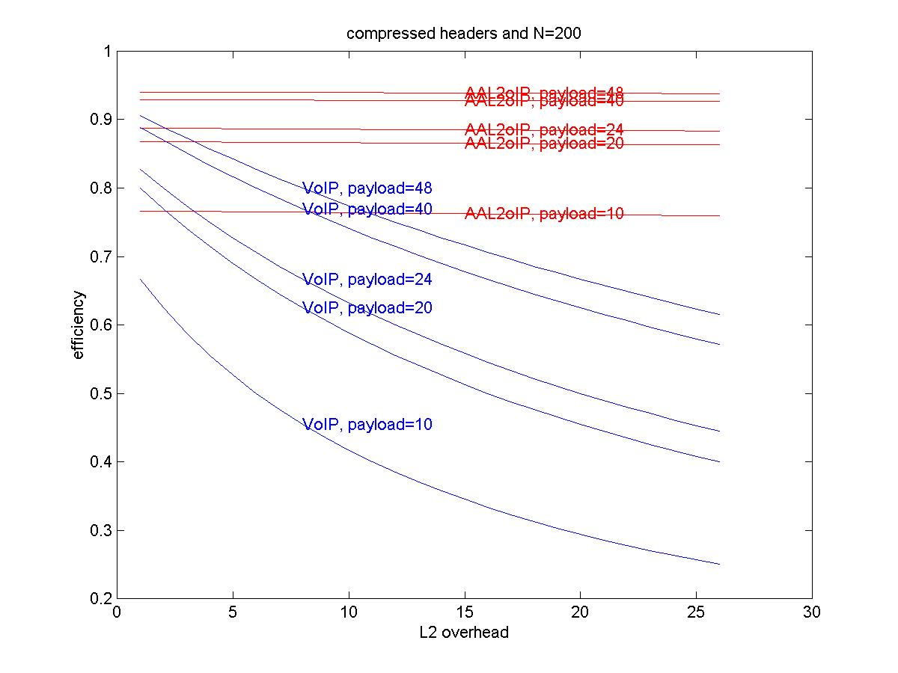
Figure 10
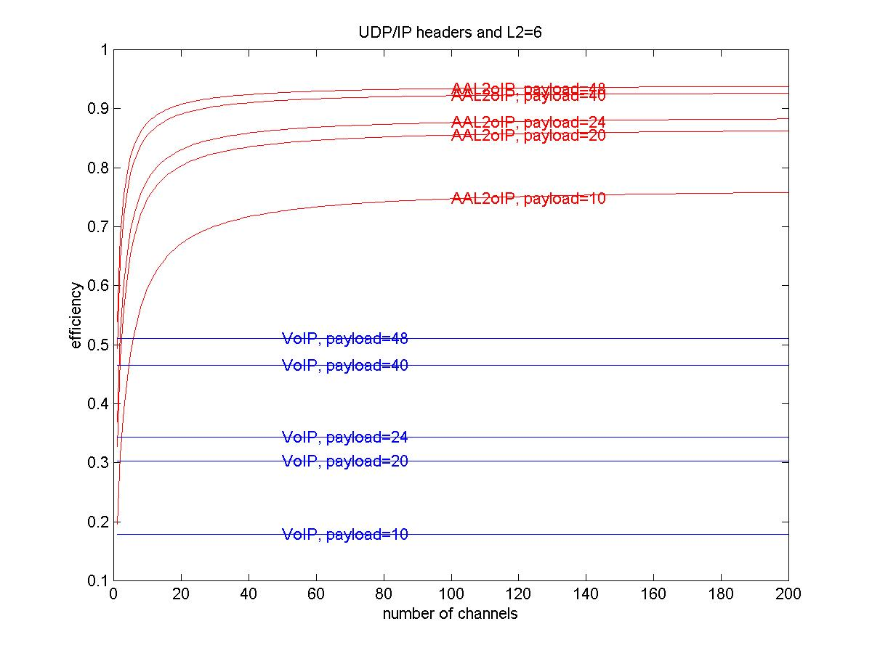
Figure 11
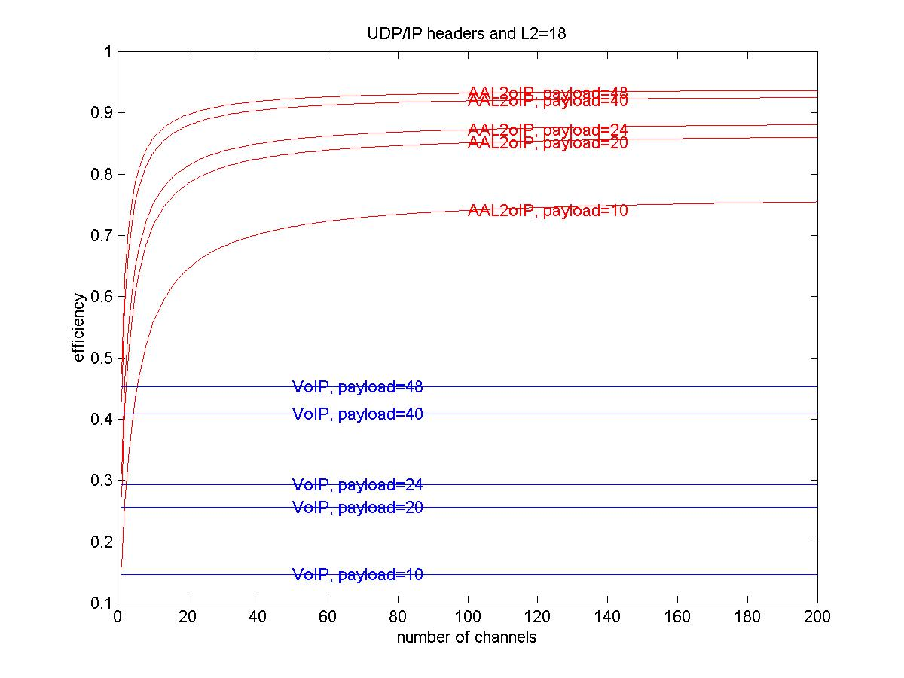
Figure 12
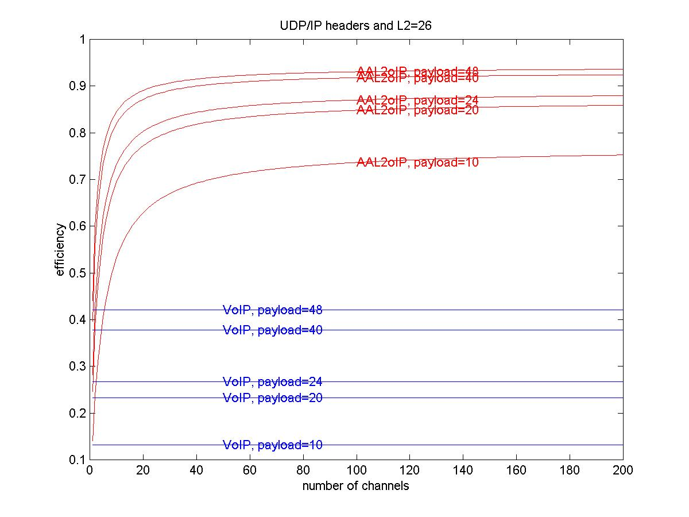
Figure 13
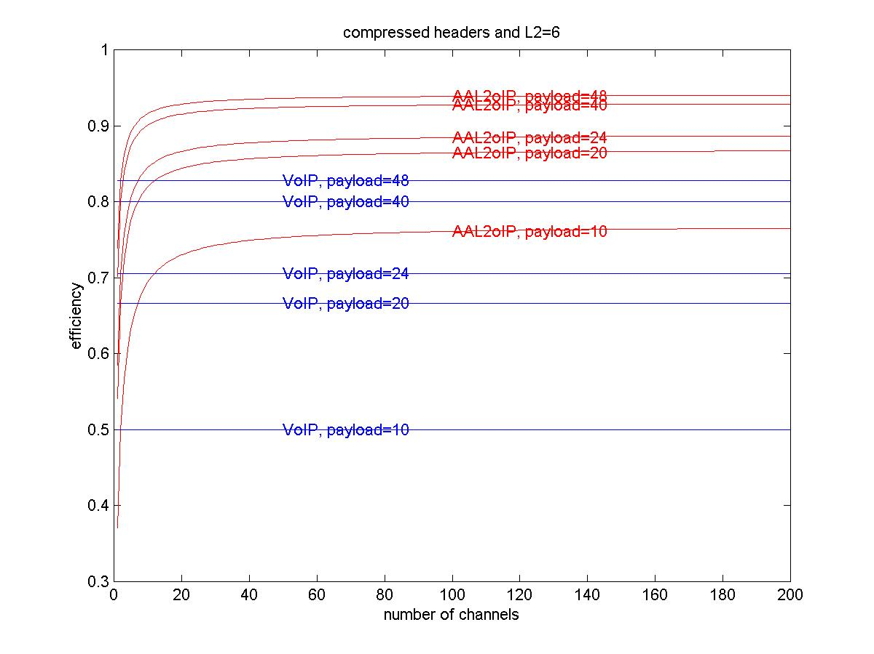
Figure 14
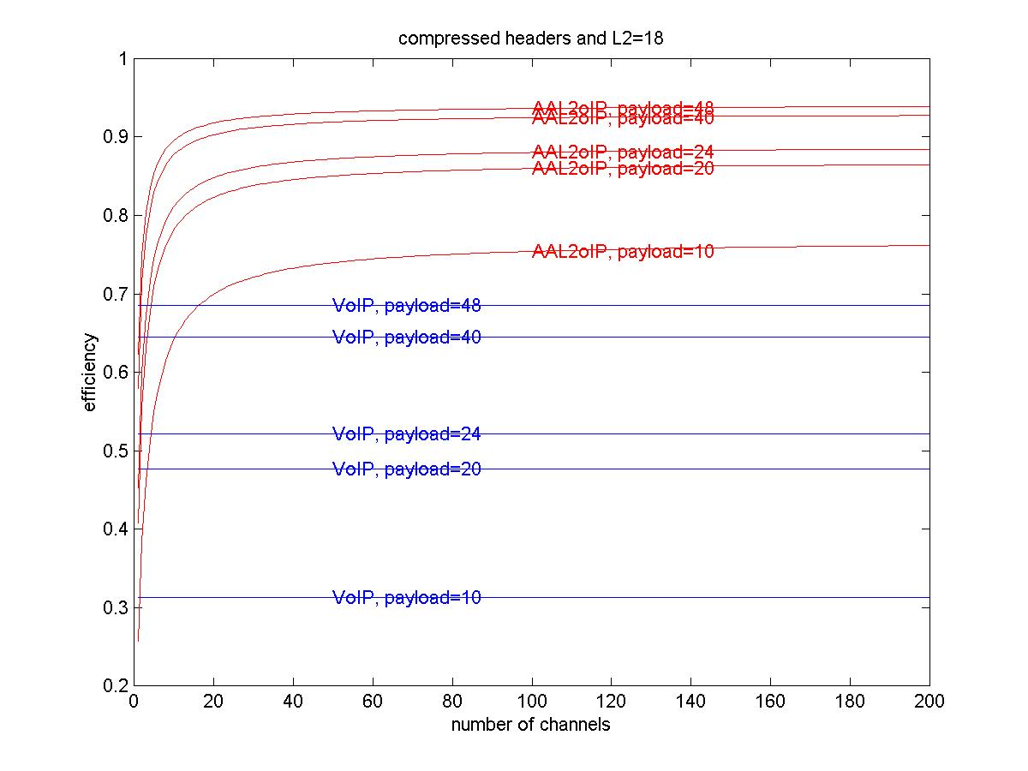
Figure 15
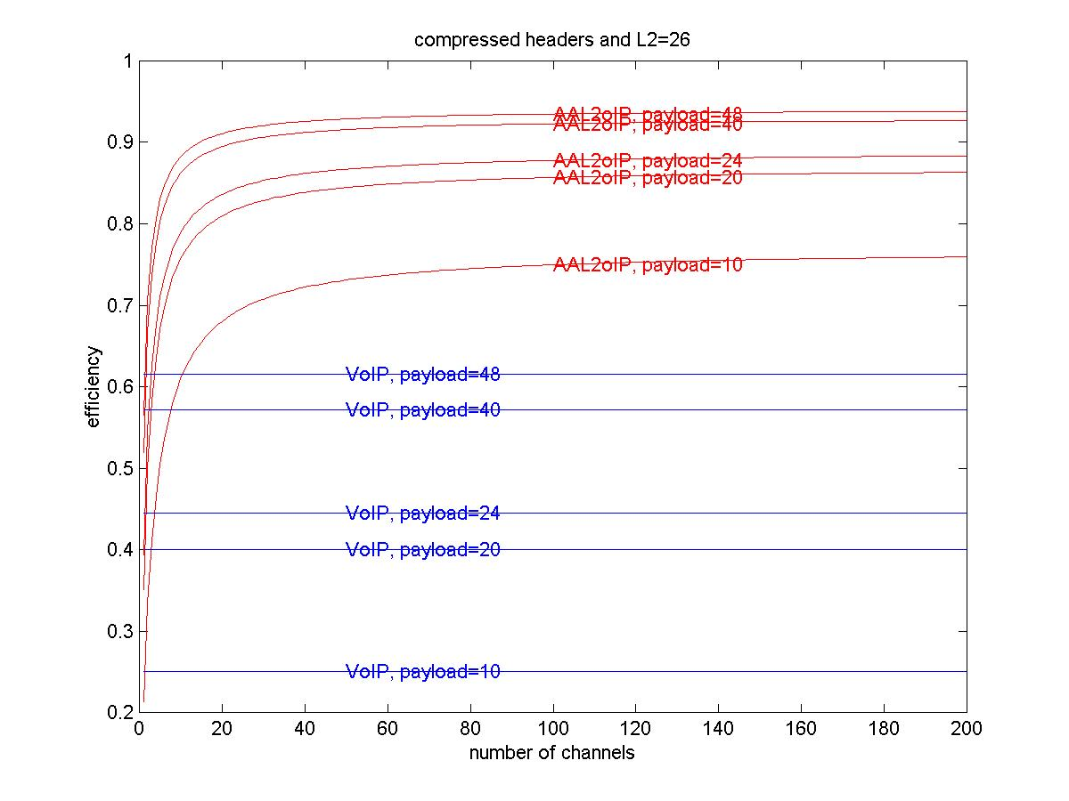
Figure 16

